Announcing the 2015 Application to the
LSAMP GLOBAL AWARENESS PROGRAM, CHIANG MAI, Thailand
Tentative dates: June 18-July 31, 2015

CSU-LSAMP will be supporting up to eight (8) students to participate in collaborative research with Thai faculty and students at Chiang Mai University, Thailand. The CSU-LSAMP program is supported by funds from the United States National Science Foundation (NSF:HRD-0802628), the CSU Office of the Chancellor, and 23 participating CSU campuses. Possible research projects are available in all of the STEM disciplines including chemistry, math and engineering.
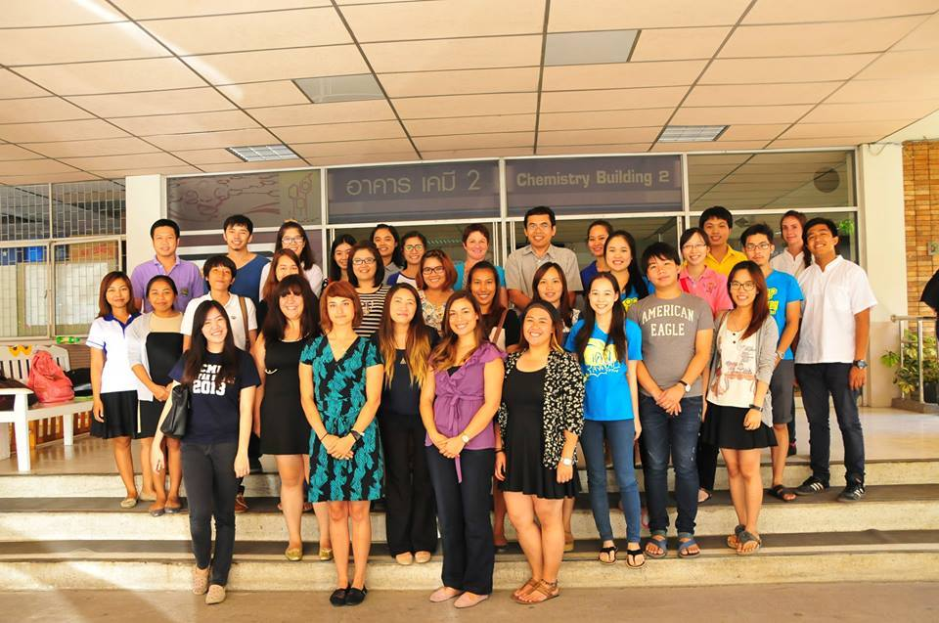
Only current, active LSAMP students with at least one semester remaining before graduation are eligible to apply. Minimum GPA in the major should be above 2.8 with at least 12 units of major core courses completed. Participants must have a current passport and will need to get a tourist visa before travel. Covered costs include return airfare travel LAX to Thailand, housing in Thailand and a per diem to cover incidentals, local travel, and food. In addition to conducting research students will also travel to cultural areas and learn about the Thai culture.

Participants will be selected on the basis of their academic qualifications and preparation, faculty and program director recommendations, ability to adapt to a different culture and climate, ability to work in a team, enthusiasm for international education and research, and the availability of project in their selected field. All applicants will be interviewed by Skype, and the initial selection of participants will begin February 23, 2015. Applications received after February 23 will be reviewed only until all places are filled. Final decisions are expected to be made by March 2, 2015.
For questions concerning the Global Awareness Program, contact the LSAMP program at CSUF LSAMP@fullerton.edu or your campus coordinator. Previous trips and student blogs are also featured on the CSUF-LSAMP facebook page at https://www.facebook.com/CSUFLSAMP/timeline

DEADLINE: For full consideration all materials should be received by 8:00am, February 23, 2015 at LSAMP@fullerton.edu. Applications are available on the web site (http://lsamp.fullerton.edu/) or by emailing LSAMP@fullerton.edu.

LOUIS STOKES ALLIANCE FOR MINORITY PARTICIPATION
GLOBAL AWARENESS THAILAND 2014
Tentative dates: June 18-July 31, 2015

DEADLINE: For full consideration all materials should be received by 8:00am, February 23, 2015 at LSAMP@fullerton.edu.

I. General Information

Gender:
Male

Female
Name:
Last First Middle

Address:
Street City Zip Code
Telephone: Email :

Social Security #: Citizenship: US. Citizen Permanent Resident
If applicable, Permanent Resident Registration #:

Ethnic Identity (for statistical purposes only)

African American Pacific Islander Hispanic/Chicano(a)/Latino(a)

American Indian Alaska Native Other (specify):

II. Educational Information

Current Campus

Credits Completed:

Your current class level: Freshman Sophomore Junior Senior

Major: Minor (if any):

Date you expect to receive your degree: Anticipated Degree:

Current G.P.A in major

Number of units completed in major

III. Statement of Purpose
In the space below, please discuss your research experience and accomplishments, career goals and what you hope to achieve by being part of the Thailand research trip. (Please type your responses into the grey box below)

Is there any additional information that you wish the application committee to consider? (Please type your response into the grey box below)
IV. Current Skills/Academic Preparation
 | No Familiarity | Familiar (seen in class or lab) | Some Experience | Experienced
Data Processing, Manipulation, Presentation and Analysis
Statistics and Probability
Computer Programming/Database Construction or Management
Basic Chromatography and Electrophoresis
Modern Instrumentation Methods (e.g. Diffraction)
Calculus and Linear Algebra
Bioinformatics - Sequence Databases, Sequence Alignment
Upper level class in Differential Equations
Molecular Modeling – Use of Biological Structure Databases and/or small molecular databases
Molecular Modeling – (e.g. Simulated Docking/Virtual Screening, visualizing and Analyzing Structures)
Math Modeling

V. Letters of Recommendation

For full consideration please arrange for two letters of recommendation to be received by 8:00am, February 23, 2015 at LSAMP@fullerton.edu. One letter should be from the LSAMP director at your home campus. One should be from a current or former research advisor or a faculty member who can discuss your potential for research. Letters should be emailed directly to LSAMP@fullerton.edu.

VII. Participation Agreement

Please read the statement below and digitally sign where indicated:

The information I have submitted in my CSU-LSAMP Global Awareness Application is true and accurate to the best of my knowledge. To be eligible for the international program I understand that I will be required to participate in various program activities as determined by the program coordinator. I understand that if selected for the program I will be expected to abide by a Code of Conduct that will be provided to me. I further understand that failure to abide by the Code of Conduct may result in dismissal from the program. I understand that all expenses that I incur, including transportation, lodging, etc. following dismissal from the program will be at my own expense. I understand that to track the progress of the CSU-LSAMP students and to evaluate program effectiveness, CSU–LSAMP requires access to student information. The CSU-LSAMP program is required to report individual student data to the National Science Foundation including social security number, ethnicity, GPA, and enrollment status. Photographs and research abstracts may also be obtained for use by the CSU-LSAMP program in program dissemination materials such as websites, newsletters, and reports. The student data are collected by the CSU-LSAMP Statewide office at California State University, Sacramento and each of the affiliated Alliance CSU campuses.

I have read and understand all of the statements above.

PRINTED NAME OF APPLICANT:

Digital Signature Date

