California State University, Fresno, Department of Biology Friday Seminar Series Presents Dr. Leroy Westerling

Recent Changes and Long Term Context for Western US Wildfire
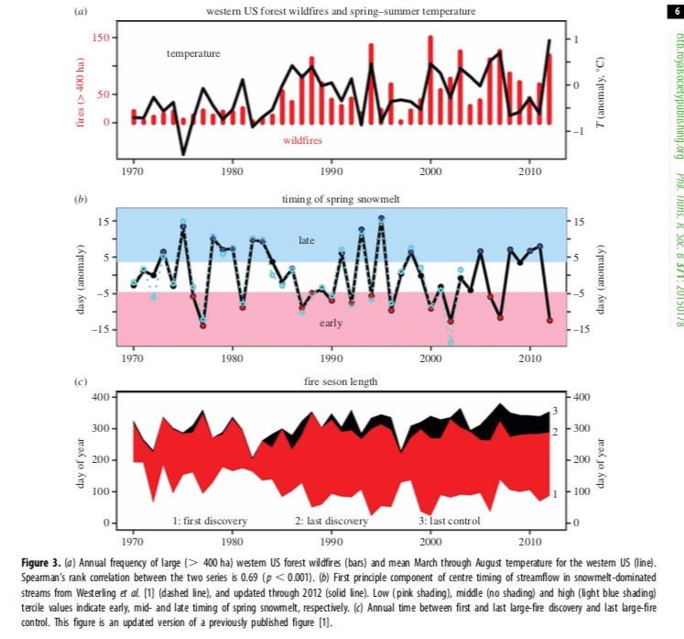
Western US forest wildfire activity increased abruptly in the mid-1980s. Large forest wildfires and areas burned in them have continued to increase over recent decades, with most of the increase in lightning-ignited fires. Northern US Rockies forests dominated early increases in wildfire activity, and still contributed 50% of the increase in large fires over the last decade. However, the percentage growth in wildfire activity in Pacific northwestern and southwestern US forests has rapidly increased over the last two decades. Wildfire numbers and burned area are also increasing in non-forest vegetation types. Wildfire activity appears strongly associated with warming and earlier spring snowmelt, and more recently with greater extremes in precipitation. We present here recent changes in fire activity around the western US as well as the context provided by the instrumental history of western US drought events, projected changes in wildfire in California and the Rockies for future climate scenarios, and hindcasts of western US forest fire activity conditional on paleoclimate reconstructions, with examples of impacts such as shifting forest species composition, seasonality of smoke emissions, changing habitat suitability, and carbon fluxes.

LeRoy Westerling, PhD
UC Merced
Friday, February 15, 2019
3:00 – 4:00 PM
Science 2, room 109
For further information: www.csufresno.edu/biology

Bio: Dr. Westerling is a Professor of Management of Complex Systems at UC Merced. He is a member of the Ernest & Julio Gallo Management Program as well as the director of the Center for Climate Communication. His research focuses on climate-ecosystem-wildfire interactions, statistical modeling paleofire reconstructions and climate change impact assessments, and resource management and policy
If you need a disability-related accommodation or wheelchair access, please contact Lindasue Garner at the Department of Biology at 278-2001 or e-mail lgarner@csufresno.edu (at least one week prior to event).

